maxspaceGUI

“maxspaceGUI” is a MATLAB script developed to support burning files into DVD-R. It aids to maximise the utility of DVD-R by finding the optimal list of files.

Last compiled version: MATLAB 2010a

How to Use

1. Open the folder “…*maxspaceGUI\maxspaceGUI\distrib*\”.
2. Type the file names wanted to be burnt and their corresponding file sizes into the excel file “*temp.xls”*.
3. Run “maxspaceGUI.exe” (MATLAB executable file).
4. Choose the DVD type, DVD-R (4.7GB) or DVD+R DL (8.5GB).
5. Click the buttom “*Optimize*”.
6. Click the buttom “*View Results*” to access the “*results.xls”*. In the “*results.xls”*, files to be burnt are listed in “sheet 1” while the unused files are stored in “sheet 2”.

Other Functions

**Import**

Read *\*.idx* files created by CD manager “**CD Index”** and convert information to a new “*temp.xls*”.

**Import Last**

Copy the “sheet 2” of “results.xls” to be “*temp.xls”*.

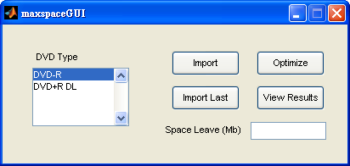

Figure User interface